Game Programming

Points System

In this tutorial I will explain how to create a score system that increases when you pick up a game object

1. First add the sprite you want to be picked up by the player to your scene. You can duplicate this as many times as you want late.
2. Create an empty game object and rename it to LevelManager. Next create a UI text element in the hierarchy.
3. Name the text in the hierarchy PointText and in its inspector set the text anchor to the top left then move the text to the top left of your canvas too. Set the text to say ‘Score:’.

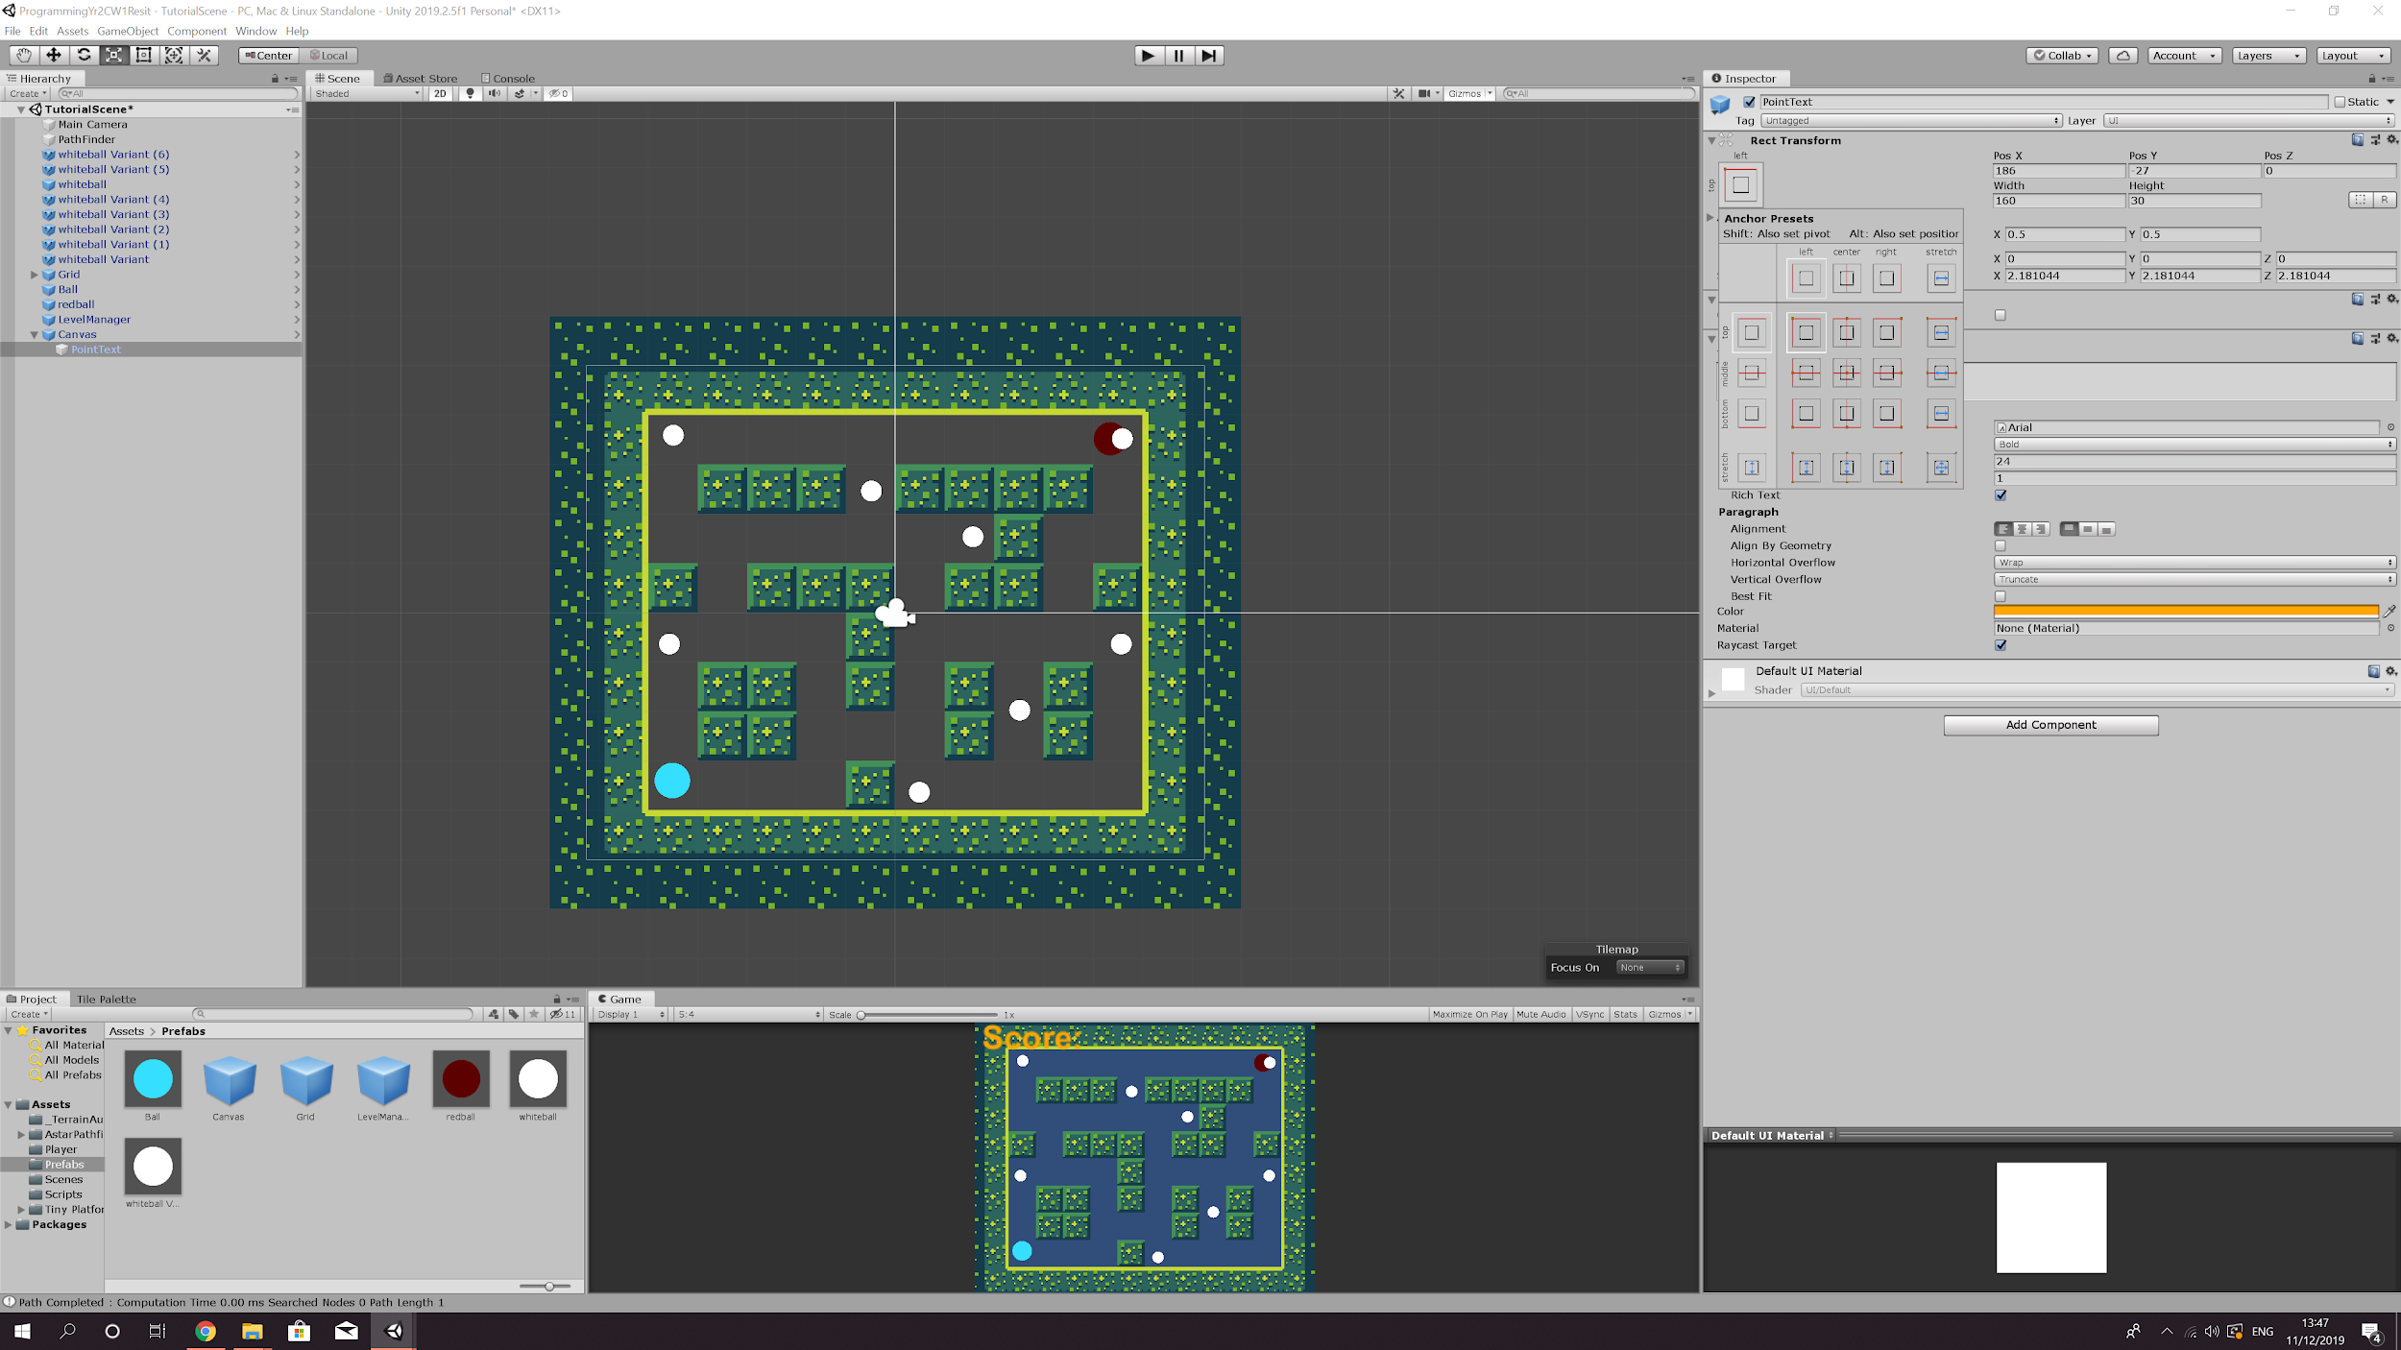

1. Now go to your scripts folder and create two C# scripts. Call one LevelManager and the other PointsScript. Open up the PointsScript. The first thing you are going to want to do is reference the level manager and you can do this with:

* private LevelManager gameLevelManager;

Then in the start function you want you type:

* gameLevelManager = FindObjectOfType<LevelManager>();

1. The next thing you have to do is destroy the sprite and increase the score. You won't be needing the update function because this is similar to how you would destroy the player when an enemy hits it, so you will need to reference the game manager again. I will demonstrate this in a screenshot below.
2. When you attach this script to your sprite and you will notice that a box allowing to change the point value appears, this changes how many points each sprite will get you. 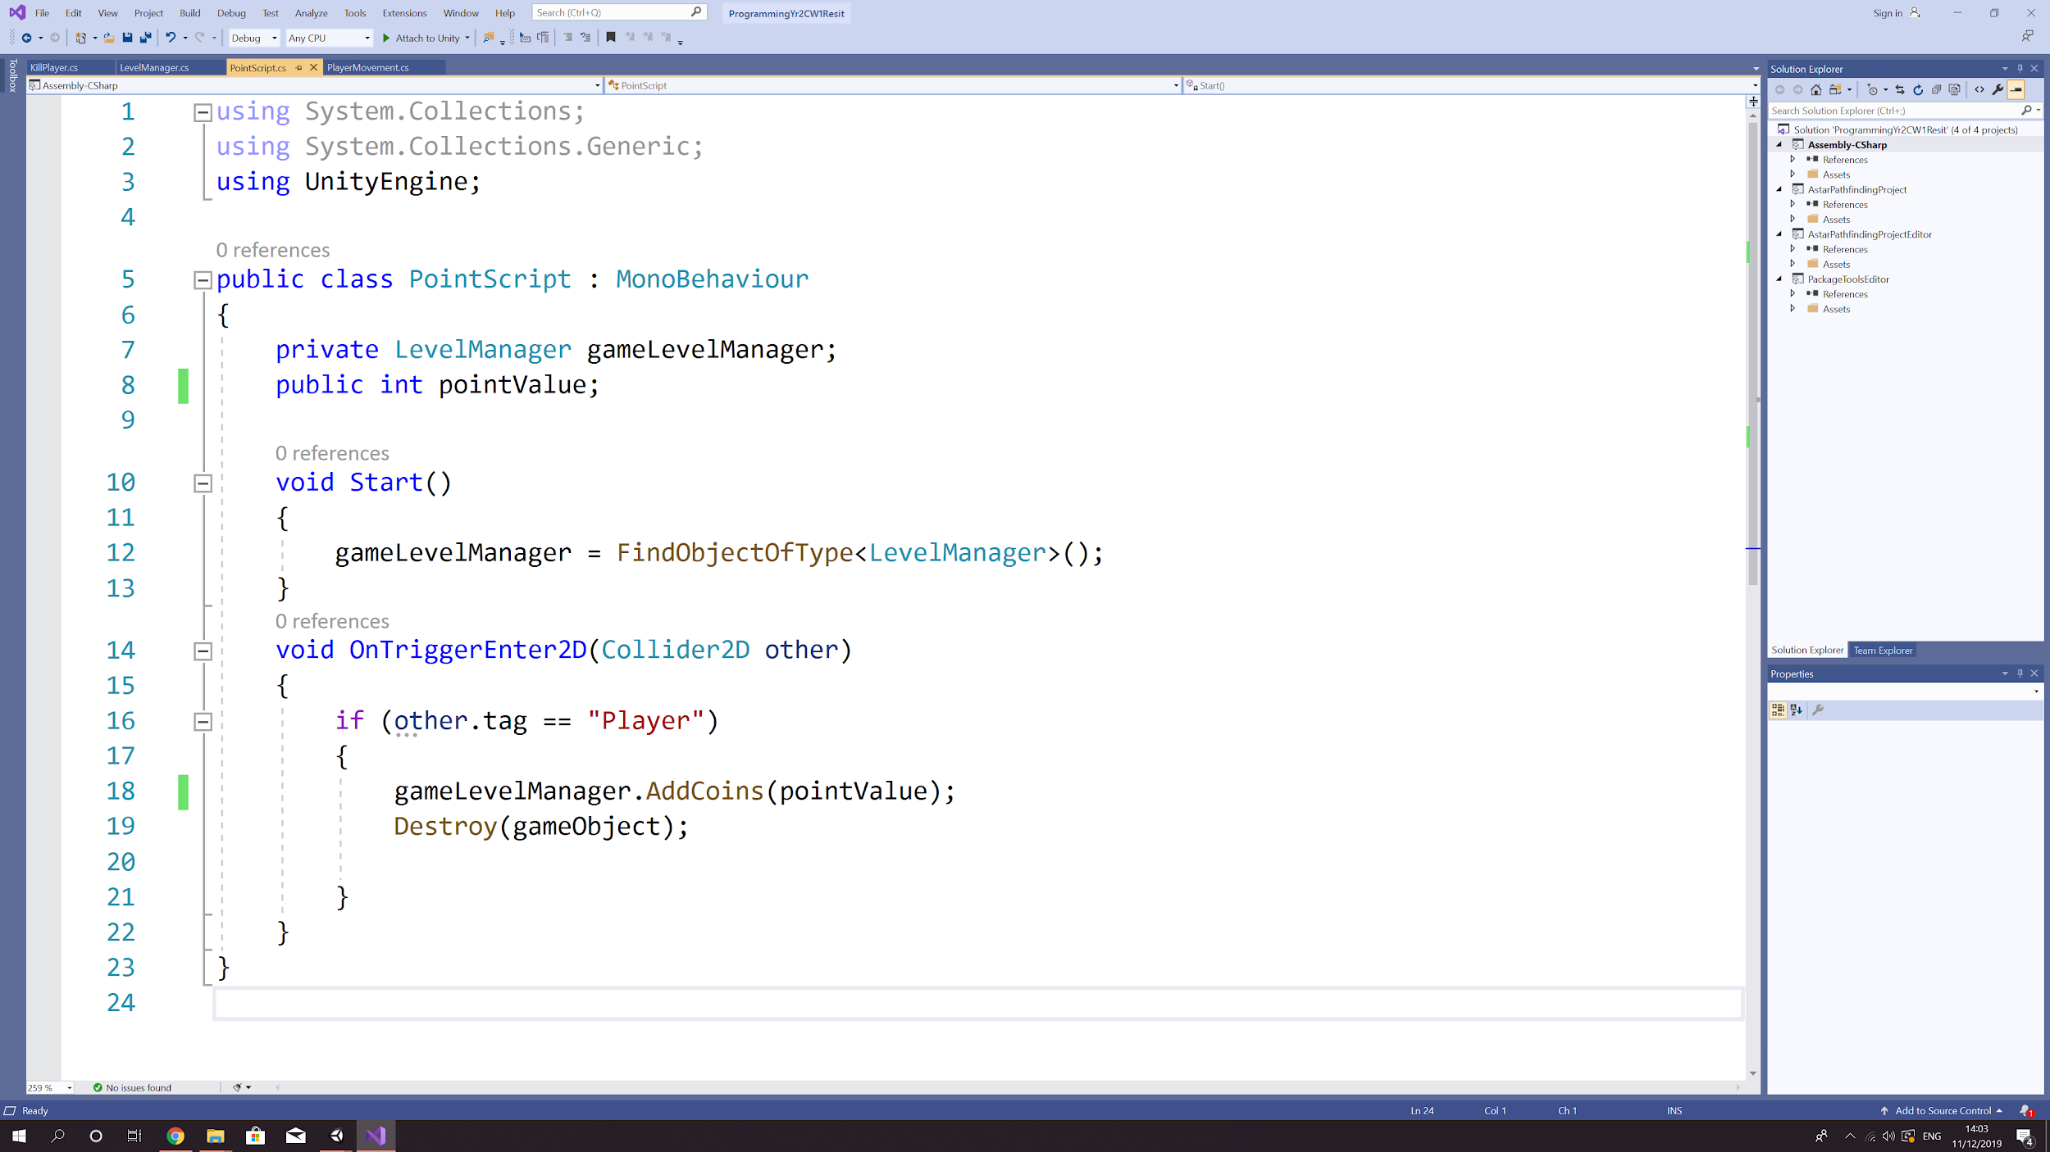

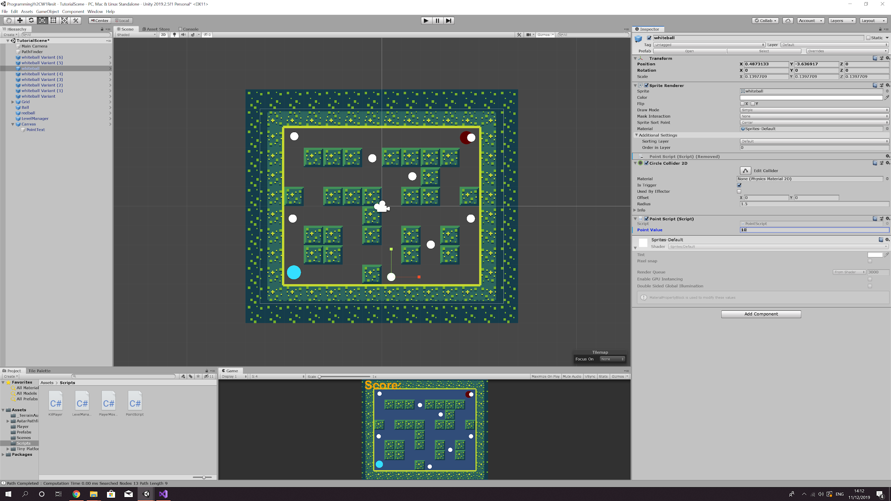

1. Open up the level manager script. This will calculate the total score and increase the score metre accordingly.

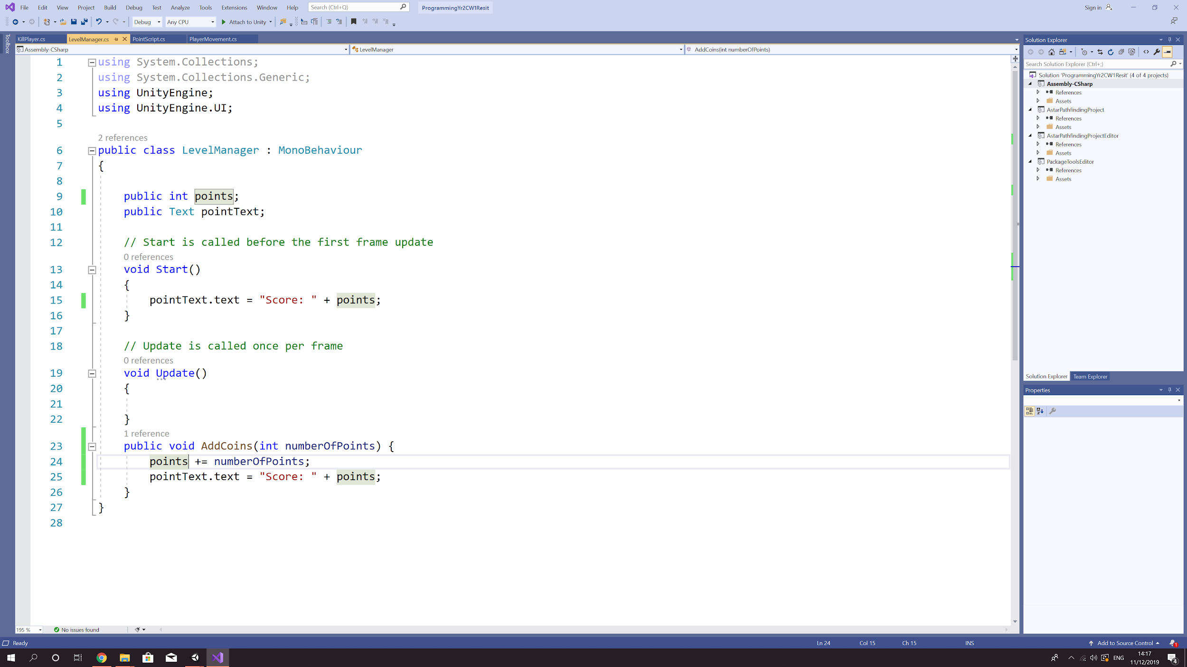

1. Attach the level manager script to the level manager game object. The script will have a box named pointText appear, drag your text from the hierarchy and drag it into box.

